OMKAR SHINDE

19/03/2023

Project Type: WEB SCRAPING

Title: SPOTIFY DATA ANALYSIS

Pictorial & Tabular Representation:

1. Heat Map: 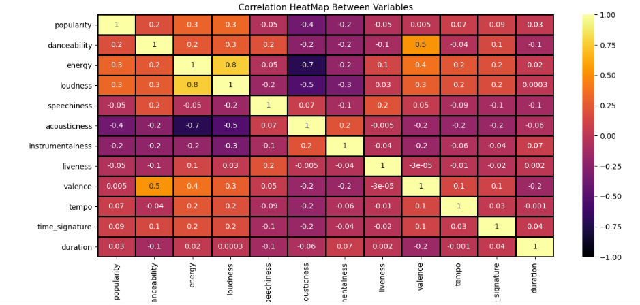
2. Regression Plot : 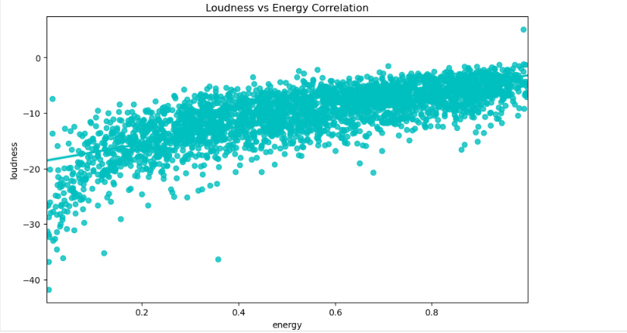

3.

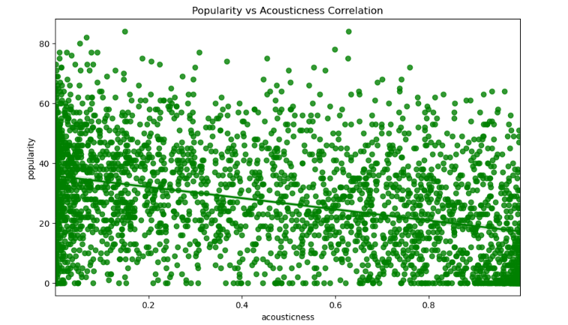

1. Distribution Plot: 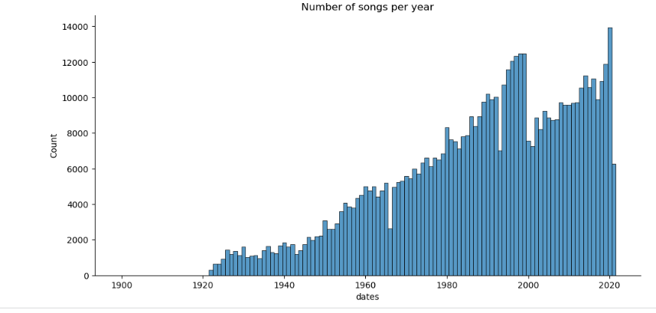
2. Bar Plot: 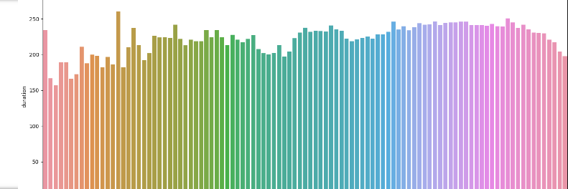
3. Line Plot: 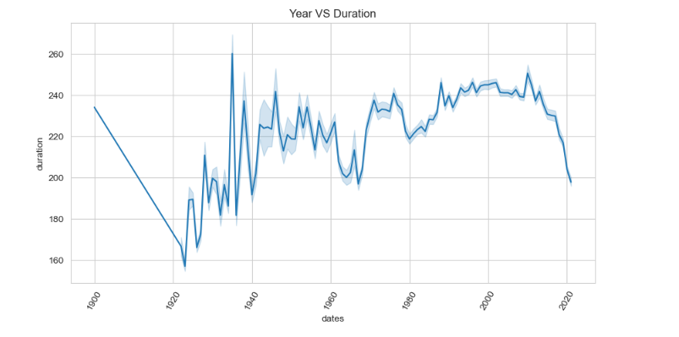
4. Bar Plot: 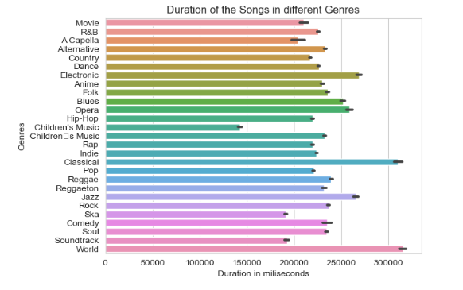
5. Bar Plot: Top 5 genres by Popularity